16.64: To produce a 10.0 Hz beat, the bat hears 2000 Hz from its own sound plus 2010 Hz coming from the wall. Call the magnitude of the bat’s speed, 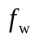 the frequency the wall receives (and reflects), and V the speed of sound.
Bat is moving source and wall is stationary observer:

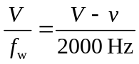 (1)

Bat is moving observer and wall is stationary source:

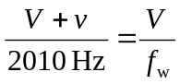 (2)

Solve (1) and (2) together:

